ANA-050 Functional Specification
Simpsons Beverages: Auto Attach Recipe Specification and Density Information to Pack V6.0

Document Properties
Authors | Eshan Fernando | Infor M3 Consultant

Approvers | Joe Walker | Solution Architect | Date: 01/12/2025
Approvers | Bevon Raj | Senior Consultant | Date: 01/12/2025

Change Control | Eshan Fernando | Creation | Date: 13/01/2026
Change Control | Eshan Fernando | Changed the way the process is initiated: Based on an event rather than a script. Minor changes to API inputs, elaborate API inputs, couple of new APIs added based on technical feedback | 29/01/2026
Change Control | Eshan Fernando | Changes to few API inputs involving descriptions in line with Simpsons data loads, add QMS009MI: AddQualityPlan | 18/02/2026
Change Control | Eshan Fernando | Refine the logic for IBC and all other lines, changes to QMS009MI: AddQualityPlan, QMS200MI: AddQISpec inputs | 23/04/2026
Change Control | Eshan Fernando | Retrieve shelf life against recipe code and update pack code | 07/07/2026
Change Control | Eshan Fernando | Adjust dates on MIXING and PACKING specification API inputs and update density when a density value exists | 08/09/2026
Change Control |  |  | Date

Contents
ANA-050 Functional Specification 1
Document Properties 1
Contents 1
Introduction 2
Functional Overview 2
Current process 2
Proposed process 2
Trigger to initiate the workflow 3
Below is the sequence in which APIs are executed. 4
Assumptions & Limitations 24

Introduction
This ANA-050 Functional Specification provides a functional solution for the Auto Attach Recipe Specification and Density Information to Pack V6.0 requested by Simpsons Beverages.
It is not intended to provide technical information. Any supporting technical information can be found in the accompanying ‘TAR-040 Technical Specification’ document, if provided.

The primary objective of this specification is to provide a functional overview of a solution to the proposed modification.

It does not consist of any training material that explains to a detailed level how the deliverables form the functional solution. It is expected that the reader of this document is to have a good understanding of any Infor M3 programs mentioned within this specification.

Functional Overview

Current process
Certain information that is pushed from PLM to M3 regarding recipe items will be relevant for pack items. Currently this information needs maintaining manually in M3 which is additional work for the team. Information such as recipe tests and density information relevant for the pack item will need to be manually attached to the pack item once the recipe item is added to the pack Bill of Material (BoM).

Proposed process
Once a recipe item (Item type Z30) is attached to a pack BOM in PDS002/U1 screen, recipe item specification header and tests will be attached to the pack item, density information on the recipe item will be multiplied based on pack size and attached to the pack item as well as weight checks added to the pack item based on density.

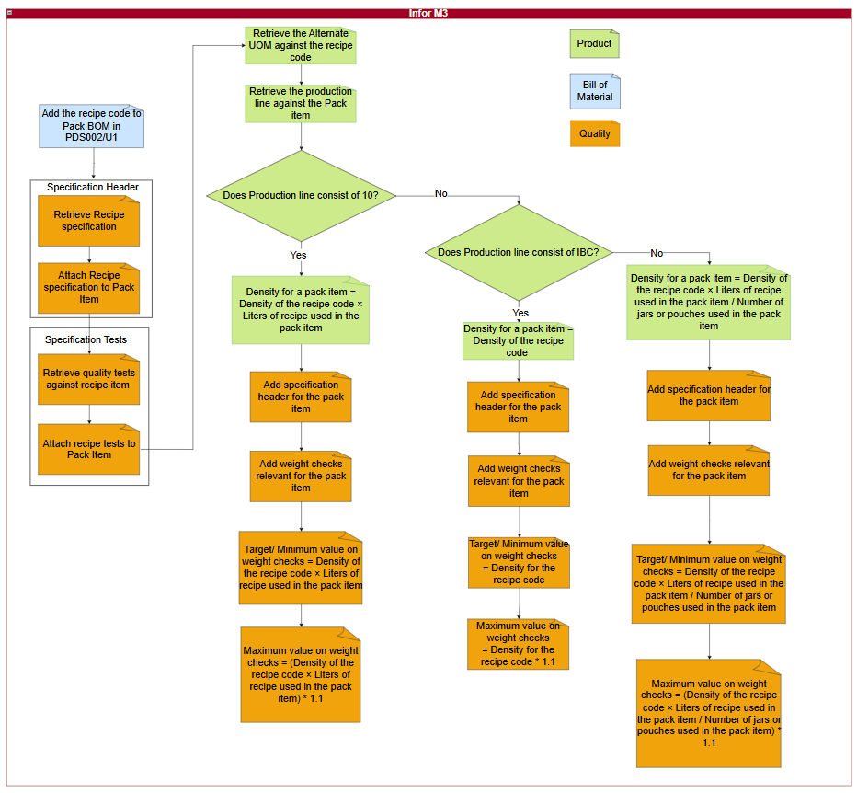
Figure 1: Information on recipes that are relevant for pack items automatically attached.

Trigger to initiate the workflow
When a recipe item is added to the product structure of a pack item, and the user navigates through PDS002/E and PDS002/F and upon returning to PDS002/U1, the workflow should be triggered. A recipe item is identified based on ‘item type’ on it being Z30 (MMITTY field in MITMAS table). This workflow should only be triggered when a recipe item is added to the product structure, and the user completes the process of adding a recipe item and returns to PDS002/U1.

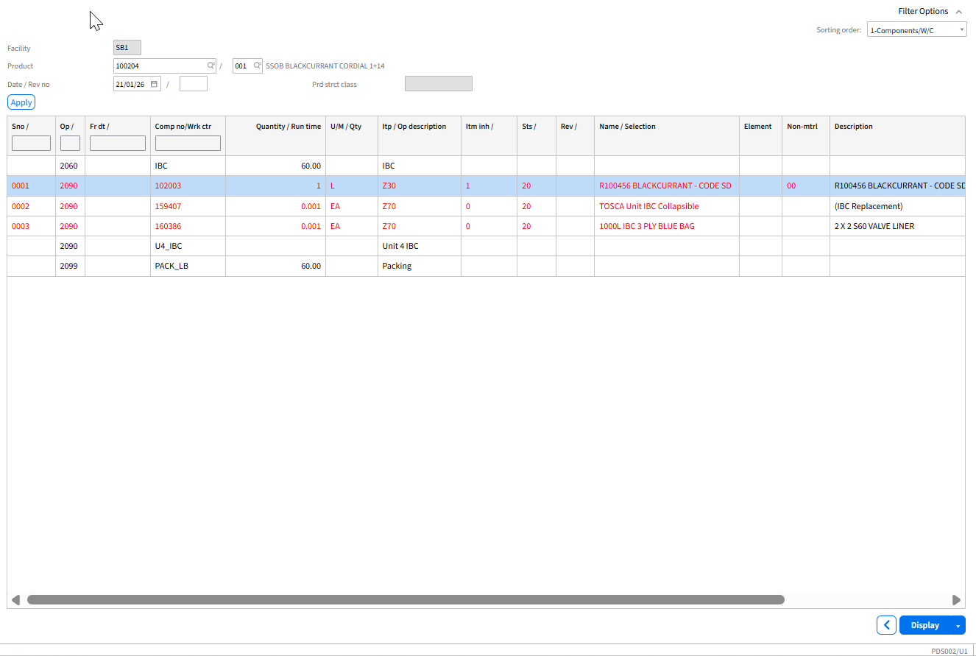
Figure 2: Recipe item in PDS002/U1
It will then execute below APIs in sequence and ensure information on recipe item is attached to the pack item.

Below is the sequence in which APIs are executed.

Step 01: Enabling ‘Item to Inherit’ flag against the ‘Z30’ record
  - API: PDS002MI
  - Transaction: UpdateComponent
Description | Field | Test Value | Extraction Method
Company | CONO | 680 | Company assigned to the user ID
Facility | FACI | SB1 | PMFACI in MPDMAT table
Product number | PRNO | 100194 | PMPRNO in MPDMAT table
Structure type | STRT | 001 | PMSTRT in MPDMAT table
Sequence number | MSEQ | 0001 | PMMSEQ in MPDMAT table
Lot Inheritance | CMCD | 1 | Hardcode to 1
Item to inherit from | INHI | 1 | Hardcode to 1
Table 1: Enabling item to inherit on Z30 item code.

Step 02: Attaching the recipe specification to pack item

Step 02.01. Retrieving the specification header for the recipe item.
  - API: CMS100MI
  - Transaction: LstQISpec
Description | Field | Test Value | Extraction Method
Item number | ITNO | 153228 | PMMTNO in MPDMAT table
Table 2: Retrieve specification header for the recipe item.
Based on inputs to Table 2, below outputs are obtained.

Description | Field | Test Value
Specification | SPEC | MIXING
Status | STAT | 20
Effective date | QSE1 | 20240101
Inactive date | QSI1 | 20301231
Description | TX40 | 153228
Auto attach | AUAT | 1
Retest | SRTT | 1
Reclass | SRCL | 0
Laboratory Manager | SPAN | WBORUKALO
Number of copies | NBEX | 1
Table 3: Output retrieved for the recipe item specification.
If multiple records are returned from Table 3, select the first record and proceed to the next step.

Step 02.02. Attach specification header record on the recipe item to the pack item
  - API: QMS200MI
  - Transaction: AddSpec
Description | Field | Test Value | Extraction Method
Item number | ITNO | 100194 | PMPRNO in MPDMAT table
Specification | SPEC | MIXING | Hardcoded
Effective date | QSE1 | 20240101 | Output from Table 3
Inactive date | QSI1 | 20301231 | Output from Table 3
Description | TX40 | 153228 | TX40 from Table 3
Status | STAT | 20 | Output from Table 3
Auto attach | AUAT | 1 | Output from Table 3
Retest | SRTT | 1 | Output from Table 3
Reclass | SRCL | 0 | Output from Table 3
Laboratory Manager | SPAN | WBORUKALO | Output from Table 3
Number of copies | NBEX | 1 | Output from Table 3
Table 4: Add Recipe specification against the pack item.

Step 03: Attaching tests to the recipe specification attached to pack item

Step 03.01. Retrieve specification tests relating to the specification header for the recipe item.
  - API: QMS201MI
  - Transaction: LstSpecTest
Description | Field | Test Value | Extraction Method
Specification | SPEC | 153228 | Output from Table 3
Effective date | QSE1 | 20240101 | Output from Table 3
Item number | ITNO | 153228 | PMMTNO in MPDMAT table
Table 5: Retrieve specification tests relating to the recipe item.
Based on inputs to Table 5, below outputs are obtained. There will be multiple records retrieved as part of this API call.

Description | Field | Test Value
Test | QTST | DENSITY
Test type | TSTY | 0
Effective date | QTE1 | 20240101
Inactive date | QTI1 | 20301231
Description | TX40 | Density
Test order | EXSQ | 1
Test result | QLCD
Expected value max | EVMX | 1.064
Expected value min | EVMN | 1.024
Expected target value | EVTG | 1.024
Test U/M | TEUM | KGL
Number of decimal places | DCCD | 5
Required | REQD | 1
Frequency times | FRTI | 1
Test classification | TCLS
Value setup | VLTP | 1
Test priority | QTSP | 1
Include test in QI request | ITQR | 1
Print test on certificate of analysis | PTCA | 1
Print test on specification document | PTSP | 1
Print spec test values | QPTT | 1
Print result value | QPTR | 1
Specification approval basis | QPLN | 9
Table 6: Output retrieved for the specification tests for recipe item.

Step 03. 02. Add specification tests to the specification in a loop for each record retrieved from Table 6
  - API: QMS201MI
  - Transaction: AddSpecTest
Description | Field | Test Value | Extraction Method
Specification | SPEC | MIXING | Hardcoded
Effective date | QSE1 | 20240101 | QSE1 from Table 3
Item number | ITNO | 100194 | PMPRNO in MPDMAT table
Test | QTST | DENSITY | Output from Table 6
Test type | TSTY | 0 | Output from Table 6
Effective date | QTE1 | 20240101 | Output from Table 6
Inactive date | QTI1 | 20301231 | Output from Table 6
Description | TX40 | Density | Output from Table 6
Test order | EXSQ | 1 | Output from Table 6
Test result | QLCD |  | Output from Table 6
Expected value max | EVMX | 1.064 | Output from Table 6
Expected value min | EVMN | 1.024 | Output from Table 6
Expected target value | EVTG | 1.024 | Output from Table 6
Test U/M | TEUM | KGL | Output from Table 6
Number of decimal places | DCCD | 5 | Output from Table 6
Required | REQD | 1 | Output from Table 6
Frequency times | FRTI | 1 | Output from Table 6
Test classification | TCLS |  | Output from Table 6
Value setup | VLTP | 1 | Output from Table 6
Test priority | QTSP | 1 | Output from Table 6
Include test in QI request | ITQR | 1 | Output from Table 6
Print test on certificate of analysis | PTCA | 1 | Output from Table 6
Print test on specification document | PTSP | 1 | Output from Table 6
Print spec test values | QPTT | 1 | Output from Table 6
Print result value | QPTR | 1 | Output from Table 6
Specification approval basis | QPLN | 9 | Output from Table 6
Table 7: Adding specification tests relating to the specification.

Step 04: Adding density against the pack item

Step 04. 01. Retrieving the alternate UOM on the recipe item.
  - API: MMS015MI
  - Transaction: Get
Description | Field | Test Value | Extraction Method
Item number | ITNO | 153228 | PMMTNO in MPDMAT table
Alternate U/M type | AUTP | 1 | Maintain this as a configurable property field so it can be updated or amended as required
Alternate U/M | ALUN | KG | Maintain this as a configurable property field so it can be updated or amended as required
Table 8: Inputs to retrieve unit of measure conversion between Kilograms and Liters on the recipe item.
Description | Field | Test Value
Conversion factor | COFA | 1.032
Conversion form | DMCF | 2
Table 9: Conversion factor and conversion form for the recipe item.
Once the conversion factor (COFA) is retrieved for the recipe item, it needs to be adjusted to calculate density against the pack item based on the production line being IBC or any other.

Step 04. 02. Retrieving the production line against the pack item.
- API: MMS200MI
  - Transaction: GetItmFac
Description | Field | Test Value | Extraction Method
Company | CONO | 680 | The company the user is logged into
Facility | FACI | SB1 | Maintain this as a configurable property field so it can be updated or amended as required
Item Number | ITNO | 153224 | PMPRNO in MPDMAT table
Table 10: Inputs to extract the production line for the pack item
Description | Field | Test Value
Production line | WCLN | 10L_A
Table 11: Production line against the pack item.

Step 04. 03. Adding the alternate UOM against the pack item.

Step 04. 03. 01. Production line on Table 11 consist of any other value except IBC (i.e. 500ML, 1L, 5L_A, 5L_B).

Step 04. 03. 01. 01. Extract quantity against the recipe code
  - API: CMS100MI
  - Transaction: LstMaterial
Description | Field | Test Value | Extraction Method
From Item to inherit | F_INHI | 1 | Maintain this as a configurable property field so it can be updated or amended as required
To item to inherit | T_INHI | 1 | Maintain this as a configurable property field so it can be updated or amended as required
Facility | FACI | SB1 | Maintain this as a configurable property field so it can be updated or amended as required
Product | ITNO | 102757 | PMPRNO in MPDMAT table
Structure type | STRT | 001 | Maintain this as a configurable property field so it can be updated or amended as required
Table 12: Inputs to extract the consumption quantity against the recipe code
Description | Field | Test Value
Quantity | CNQT | 20
Table 13: Consumption quantity against the recipe code.

Step 04. 03. 01. 02. Extract quantity against the jar or pouch or whichever the packaging used
  - API: CMS100MI
  - Transaction: LstMaterial
Description | Field | Test Value | Extraction Method
From Critical mtrl | F_CRTM | 1 | Maintain this as a configurable property field so it can be updated or amended as required
To Critical mtrl | T_CRTM | 1 | Maintain this as a configurable property field so it can be updated or amended as required
Facility | FACI | SB1 | Maintain this as a configurable property field so it can be updated or amended as required
Product | ITNO | 102757 | PMPRNO in MPDMAT table
Structure type | STRT | 001 | Maintain this as a configurable property field so it can be updated or amended as required
Table 14: Inputs to extract the consumption quantity against the jar or pouch
Description | Field | Test Value
Quantity | CNQT | 4
Table 15: Consumption quantity against the jar or pouch.

Step 04. 03. 01. 03. Add density against the pack code
  - API: MMS015MI
  - Transaction: Add
Description | Field | Test Value | Extraction Method
Item number | ITNO | 153224 | PMPRNO in MPDMAT table
Alternate U/M type | AUTP | 1 | Maintain this as a configurable property field so it can be updated or amended as required
Alternate U/M | ALUN | DPP | Maintain this as a configurable property field so it can be updated or amended as required
Number of decimal places | DCCD | 2 | Maintain this as a configurable property field so it can be updated or amended as required
Conversion factor | COFA | 5.15 | Conversion factor (COFA) on Table 9 * CNQT value on Table 13/ CNQT value on Table 15
Conversion form | DMCF | 2 | Output from Table 9
Standard U/M - Manufacturing | AUS3 | 0 | Maintain this as a configurable property field so it can be updated or amended as required
Table 16: Inputs to add unit of measure conversion between Kilograms and Liters against pack item.
In the event Step 04. 03. 01. 03. fails due to an existing record, proceed to Step 04. 03. 01. 04., else proceed to Step 04. 03. 01. 05..

Step 04. 03. 01. 04.: Updating density against recipe code.
  - API: MMS015MI
  - Transaction: Upd
Description | Field | Test Value | Extraction Method
Item number | ITNO | 153224 | PMPRNO in MPDMAT table
Alternate U/M type | AUTP | 1 | Maintain this as a configurable property field so it can be updated or amended as required
Alternate U/M | ALUN | DPP | Maintain this as a configurable property field so it can be updated or amended as required
Number of decimal places | DCCD | 2 | Maintain this as a configurable property field so it can be updated or amended as required
Conversion factor | COFA | 5.15 | Conversion factor (COFA) on Table 9 * CNQT value on Table 13/ CNQT value on Table 15
Conversion form | DMCF | 2 | Output from Table 9
Standard U/M - Manufacturing | AUS3 | 0 | Maintain this as a configurable property field so it can be updated or amended as required
Table 17: Inputs to update unit of measure conversion between Kilograms and Liters

Step 04. 03. 01. 05. Add a quality plan against the pack item
  - API: QMS009MI
  - Transaction: AddQualityPlan
Description | Field | Test Value | Extraction Method
Quality plan | QLPN | PACK | Hardcoded
Item number | ITNO | 102757 | PMPRNO in MPDMAT table
Description | TX40 | 102757 | PMPRNO in MPDMAT table
Active | ACTF | 1 | Maintain as a configurable field in a parameter file if needs amending later
Changing QI request | QIMD | 0 | Maintain as a configurable field in a parameter file if needs amending later
Adding test to QI req | QIAT | 1 | Maintain as a configurable field in a parameter file if needs amending later
Spec approval basis | QPLN | 0 | Maintain as a configurable field in a parameter file if needs amending later
QI req appr basis | QPLT | 0 | Maintain as a configurable field in a parameter file if needs amending later
Approval passed/passed | QAPP | 1 | Maintain as a configurable field in a parameter file if needs amending later
Approval passed/failed | QAPF | 1 | Maintain as a configurable field in a parameter file if needs amending later
Approval passed/not tested | QAPN | 1 | Maintain as a configurable field in a parameter file if needs amending later
Approval passed/none | QAPE | 1 | Maintain as a configurable field in a parameter file if needs amending later
Approval failed/passed | QAFP | 3 | Maintain as a configurable field in a parameter file if needs amending later
Approval failed/failed | QAFF | 3 | Maintain as a configurable field in a parameter file if needs amending later
Approval failed/not tested | QAFN | 3 | Maintain as a configurable field in a parameter file if needs amending later
Approval failed/none | QAFE | 3 | Maintain as a configurable field in a parameter file if needs amending later
Approval not tested/passed | QANP | 3 | Maintain as a configurable field in a parameter file if needs amending later
Approval not tested/passed | QANF | 3 | Maintain as a configurable field in a parameter file if needs amending later
Approval not tested/not tested | QANN | 3 | Maintain as a configurable field in a parameter file if needs amending later
Approval not tested/none | QANE | 3 | Maintain as a configurable field in a parameter file if needs amending later
Approval none/passed | QAEP | 3 | Maintain as a configurable field in a parameter file if needs amending later
Approval none/failed | QAEF | 3 | Maintain as a configurable field in a parameter file if needs amending later
Approval none/not tested | QAEN | 3 | Maintain as a configurable field in a parameter file if needs amending later
Lot auto-approval | QLTA | 1 | Maintain as a configurable field in a parameter file if needs amending later
Spec auto-approval | QSPA | 1 | Maintain as a configurable field in a parameter file if needs amending later
QI request auto-approval | QIRA | 1 | Maintain as a configurable field in a parameter file if needs amending later
QI request level | QRLV | 0 | Maintain as a configurable field in a parameter file if needs amending later
Manual QI req status | QST1 | 1 | Maintain as a configurable field in a parameter file if needs amending later
Default QI req as test at pre-ship | TPS2 | 0 | Maintain as a configurable field in a parameter file if needs amending later
Test freq basis for PO | QIFR | 0 | Maintain as a configurable field in a parameter file if needs amending later
Replace PO QI request | QIRP | 0 | Maintain as a configurable field in a parameter file if needs amending later
Test freq basis for MO | QIF1 | 0 | Maintain as a configurable field in a parameter file if needs amending later
Replace MO QI request | QIPF | 0 | Maintain as a configurable field in a parameter file if needs amending later
Create QI request on CO returns | QCRF | 0 | Maintain as a configurable field in a parameter file if needs amending later
Copy QI request on new lot | QCRO | 0 | Maintain as a configurable field in a parameter file if needs amending later
Auto-reinspection of lots | QARE | 0 | Maintain as a configurable field in a parameter file if needs amending later
QI reinspection level | QARL | 0 | Maintain as a configurable field in a parameter file if needs amending later
Reinspection generation basis | QARB | 0 | Maintain as a configurable field in a parameter file if needs amending later
Reinspection calculation date | QARD | 0 | Maintain as a configurable field in a parameter file if needs amending later
Manual update of calculated test | QMTU | 0 | Maintain as a configurable field in a parameter file if needs amending later
Table 18: Add a quality plan against the pack item.

Step 04. 03. 01. 06. Add specification header to the pack item so that weight checks can be added against the pack item.
  - API: QMS200MI
  - Transaction: AddSpec
Description | Field | Test Value | Extraction Method
Item number | ITNO | 100194 | PMPRNO in MPDMAT table
Specification | SPEC | PACKING | Hardcoded
Effective date | QSE1 | 20240101 | QSE1 in Table 3
Inactive date | QSI1 | 20501231 | QSI1 in Table 3
Description | TX40 | 100194 | PMPRNO in MPDMAT table
Status | STAT | 20 | Maintain this as a configurable property field so it can be updated or amended as required
Auto attach | AUAT | 1 | Maintain this as a configurable property field so it can be updated or amended as required
Retest | SRTT | 1 | Maintain this as a configurable property field so it can be updated or amended as required
Reclass | SRCL | 0 | Maintain this as a configurable property field so it can be updated or amended as required
Laboratory Manager | SPAN | WBORUKALO | Hardcoded
Number of copies | NBEX | 1 | Maintain this as a configurable property field so it can be updated or amended as required
Table 19: Add Recipe specification against the pack item.

Step 04. 03. 01. 07. Retrieve relevant pack tests
  - API: CRS881MI
  - Transaction: LstTranslation
Description | Field | Test Value | Extraction Method
Record type | TRQF | 1 | Hardcoded
Message standard | MSTD | PACKING | Hardcoded
Message version | MVRS | 1 | Hardcoded
Business message | BMSG | PACKTESTS | Hardcoded
Inbound or outbound message | IBOB | I | Hardcoded
Parent element | ELMP | PackTests | Hardcoded
Data element | ELMD | Packing | Hardcoded
Table 20: Inputs to extract pack test details from translation table
Description | Field | Test Value
Movex Data | MVXD | WEIGHT-A
Table 21: Pack Tests retrieved

Step 04. 03. 01. 08. Retrieve details relating to weight checks.
  - API: CMS100MI
  - Transaction: LstTestDetail
Description | Field | Test Value | Extraction Method
Test | QSQTST | WEIGHT-A | Needs to be executed in a loop for each value retrieved from Table 21
Table 22: Inputs to extract details against weight checks
Description | Field | Test Value
Test | QTST | WEIGHT-A
Test type | TSTY | 0
Effective date | QTE1 | 20240101
Inactive date | QTI1 | 20501231
Description | TX40 | Weight check 1
Test order | EXSQ | 1
Test U/M | TEUM | KG
Number of decimal places | DCCD | 6
Required | REQD | 1
Frequency times | FRTI | 1
Test classification | TCLS
Value setup | VLTP | 1
Test priority | QTSP | 1
Spec appro bas | QPLN | 9
Table 23: Details against weight checks.

Step 04. 03. 01. 08. Add specification tests relating to the pack item to the specification. This needs to be run in a loop for each record retrieved from Table 23.
  - API: QMS201MI
  - Transaction: AddSpecTest
Description | Field | Test Value | Extraction Method
Specification | SPEC | PACKING | Hardcoded
Effective date | QSE1 | 20240101 | QSE1 in Table 3
Item number | ITNO | 100194 | PMPRNO in MPDMAT table
Test | QTST | WEIGHT-A | QTST from Table 23.
Test type | TSTY | 0 | TSTY output in Table 23
Effective date | QTE1 | 20240101 | QTE1 output in Table 23
Inactive date | QTI1 | 20501231 | QTI1 output in Table 23
Description | TX40 | Weight check 1 | TX40 output in Table 23
Test order | EXSQ | 1 | EXSQ output in Table 23
Test result | QLCD |  | Blank value
Expected value max | EVMX | 5.67 | Conversion factor (COFA) on Table 9 * CNQT value on Table 13/ CNQT value on Table 15 + 10%
Expected value min | EVMN | 5.15 | Conversion factor (COFA) on Table 9 * CNQT value on Table 13/ CNQT value on Table 15
Expected target value | EVTG | 5.15 | Conversion factor (COFA) on Table 9 * CNQT value on Table 13/ CNQT value on Table 15
Test U/M | TEUM | KG | TEUM output in Table 23
Number of decimal places | DCCD | 5 | DCCD output in Table 23
Required | REQD | 1 | REQD output in Table 23
Frequency times | FRTI | 1 | FRTI output in Table 23
Test classification | TCLS | PHYSICAL | TCLS output in Table 23
Value setup | VLTP | 1 | VLTP output in Table 23
Test priority | QTSP | 1 | QTSP output in Table 23
Include test in QI request | ITQR | 1 | Hardcode to 1
Print test on certificate of analysis | PTCA | 1 | Hardcode to 1
Print test on specification document | PTSP | 1 | Hardcode to 1
Print spec test values | QPTT | 1 | Hardcode to 1
Print result value | QPTR | 1 | Hardcode to 1
Specification approval basis | QPLN | 9 | QPLN output in Table 23
Table 24: Adding specification tests relating to the pack item specification.
Weight check needs to be added to the pack specification for each of the outputs from Table 23.

Step 04. 03. 02. In the event production line on Table 11 consist of a value containing IBC (i.e. IBC, U4_IBC).

Step 04. 03. 02. 01. Add density against the pack code
  - API: MMS015MI
  - Transaction: Add
Description | Field | Test Value | Extraction Method
Item number | ITNO | 153224 | PMPRNO in MPDMAT table
Alternate U/M type | AUTP | 1 | Maintain this as a configurable property field so it can be updated or amended as required
Alternate U/M | ALUN | KG | Maintain this as a configurable property field so it can be updated or amended as required
Number of decimal places | DCCD | 2 | Maintain this as a configurable property field so it can be updated or amended as required
Conversion factor | COFA | 1.032 | Conversion factor (COFA) on Table 9
Conversion form | DMCF | 2 | Output from Table 9
Standard U/M - Manufacturing | AUS3 | 1 | Maintain this as a configurable property field so it can be updated or amended as required
Table 25: Inputs to add unit of measure conversion between Kilograms and Liters against pack item.
In the event Step 04. 03. 02. 01. fails due to an existing record, proceed to Step 04. 03. 02. 02., else proceed to Step 04. 03. 02. 03..

Step 04. 03. 02. 02.: Updating density against recipe code.
  - API: MMS015MI
  - Transaction: Upd
Description | Field | Test Value | Extraction Method
Item number | ITNO | 153224 | PMPRNO in MPDMAT table
Alternate U/M type | AUTP | 1 | Maintain this as a configurable property field so it can be updated or amended as required
Alternate U/M | ALUN | KG | Maintain this as a configurable property field so it can be updated or amended as required
Number of decimal places | DCCD | 2 | Maintain this as a configurable property field so it can be updated or amended as required
Conversion factor | COFA | 1.032 | Conversion factor (COFA) on Table 9
Conversion form | DMCF | 2 | Output from Table 9
Standard U/M - Manufacturing | AUS3 | 1 | Maintain this as a configurable property field so it can be updated or amended as required
Table 26: Inputs to update unit of measure conversion between Kilograms and Liters

Step 04. 03. 02. 03. Add a quality plan against the pack item
  - API: QMS009MI
  - Transaction: AddQualityPlan
Description | Field | Test Value | Extraction Method
Quality plan | QLPN | PACK | Hardcoded
Item number | ITNO | 102757 | PMPRNO in MPDMAT table
Description | TX40 | 102757 | PMPRNO in MPDMAT table
Active | ACTF | 1 | Maintain as a configurable field in a parameter file if needs amending later
Changing QI request | QIMD | 0 | Maintain as a configurable field in a parameter file if needs amending later
Adding test to QI req | QIAT | 1 | Maintain as a configurable field in a parameter file if needs amending later
Spec approval basis | QPLN | 0 | Maintain as a configurable field in a parameter file if needs amending later
QI req appr basis | QPLT | 0 | Maintain as a configurable field in a parameter file if needs amending later
Approval passed/passed | QAPP | 1 | Maintain as a configurable field in a parameter file if needs amending later
Approval passed/failed | QAPF | 1 | Maintain as a configurable field in a parameter file if needs amending later
Approval passed/not tested | QAPN | 1 | Maintain as a configurable field in a parameter file if needs amending later
Approval passed/none | QAPE | 1 | Maintain as a configurable field in a parameter file if needs amending later
Approval failed/passed | QAFP | 3 | Maintain as a configurable field in a parameter file if needs amending later
Approval failed/failed | QAFF | 3 | Maintain as a configurable field in a parameter file if needs amending later
Approval failed/not tested | QAFN | 3 | Maintain as a configurable field in a parameter file if needs amending later
Approval failed/none | QAFE | 3 | Maintain as a configurable field in a parameter file if needs amending later
Approval not tested/passed | QANP | 3 | Maintain as a configurable field in a parameter file if needs amending later
Approval not tested/passed | QANF | 3 | Maintain as a configurable field in a parameter file if needs amending later
Approval not tested/not tested | QANN | 3 | Maintain as a configurable field in a parameter file if needs amending later
Approval not tested/none | QANE | 3 | Maintain as a configurable field in a parameter file if needs amending later
Approval none/passed | QAEP | 3 | Maintain as a configurable field in a parameter file if needs amending later
Approval none/failed | QAEF | 3 | Maintain as a configurable field in a parameter file if needs amending later
Approval none/not tested | QAEN | 3 | Maintain as a configurable field in a parameter file if needs amending later
Lot auto-approval | QLTA | 1 | Maintain as a configurable field in a parameter file if needs amending later
Spec auto-approval | QSPA | 1 | Maintain as a configurable field in a parameter file if needs amending later
QI request auto-approval | QIRA | 1 | Maintain as a configurable field in a parameter file if needs amending later
QI request level | QRLV | 0 | Maintain as a configurable field in a parameter file if needs amending later
Manual QI req status | QST1 | 1 | Maintain as a configurable field in a parameter file if needs amending later
Default QI req as test at pre-ship | TPS2 | 0 | Maintain as a configurable field in a parameter file if needs amending later
Test freq basis for PO | QIFR | 0 | Maintain as a configurable field in a parameter file if needs amending later
Replace PO QI request | QIRP | 0 | Maintain as a configurable field in a parameter file if needs amending later
Test freq basis for MO | QIF1 | 0 | Maintain as a configurable field in a parameter file if needs amending later
Replace MO QI request | QIPF | 0 | Maintain as a configurable field in a parameter file if needs amending later
Create QI request on CO returns | QCRF | 0 | Maintain as a configurable field in a parameter file if needs amending later
Copy QI request on new lot | QCRO | 0 | Maintain as a configurable field in a parameter file if needs amending later
Auto-reinspection of lots | QARE | 0 | Maintain as a configurable field in a parameter file if needs amending later
QI reinspection level | QARL | 0 | Maintain as a configurable field in a parameter file if needs amending later
Reinspection generation basis | QARB | 0 | Maintain as a configurable field in a parameter file if needs amending later
Reinspection calculation date | QARD | 0 | Maintain as a configurable field in a parameter file if needs amending later
Manual update of calculated test | QMTU | 0 | Maintain as a configurable field in a parameter file if needs amending later
Table 27: Add a quality plan against the pack item.

Step 04. 03. 02. 04. Add specification header to the pack item so that weight checks can be added
  - API: QMS200MI
  - Transaction: AddSpec
Description | Field | Test Value | Extraction Method
Item number | ITNO | 100194 | PMPRNO in MPDMAT table
Specification | SPEC | PACKING | Hardcoded
Effective date | QSE1 | 20240101 | QSE1 in Table 3
Inactive date | QSI1 | 20501231 | QSI1 in Table 3
Description | TX40 | 100194 | PMPRNO in MPDMAT table
Status | STAT | 20 | Maintain this as a configurable property field so it can be updated or amended as required
Auto attach | AUAT | 1 | Maintain this as a configurable property field so it can be updated or amended as required
Retest | SRTT | 1 | Maintain this as a configurable property field so it can be updated or amended as required
Reclass | SRCL | 0 | Maintain this as a configurable property field so it can be updated or amended as required
Laboratory Manager | SPAN | WBORUKALO | Hardcoded
Number of copies | NBEX | 1 | Maintain this as a configurable property field so it can be updated or amended as required
Table 28: Add Recipe specification against the pack item.

Step 04. 03. 02. 05. Retrieve relevant pack tests
  - API: CRS881MI
  - Transaction: LstTranslation
Description | Field | Test Value | Extraction Method
Record type | TRQF | 1 | Hardcoded
Message standard | MSTD | PACKING | Hardcoded
Message version | MVRS | 1 | Hardcoded
Business message | BMSG | PACKTESTS | Hardcoded
Inbound or outbound message | IBOB | I | Hardcoded
Parent element | ELMP | PackTests | Hardcoded
Data element | ELMD | Packing | Hardcoded
Table 29: Inputs to extract pack test details from translation table
Description | Field | Test Value
Movex Data | MVXD | WEIGHT-A
Table 30: Pack Tests retrieved

Step 04. 03. 02. 06. Retrieve details relating to weight checks.
  - API: CMS100MI
  - Transaction: LstTestDetail
Description | Field | Test Value | Extraction Method
Test | QSQTST | WEIGHT-A | Needs to be executed in a loop for each value retrieved from Table 30
Table 31: Inputs to extract details against weight checks
Description | Field | Test Value
Test | QTST | WEIGHT-A
Test type | TSTY | 0
Effective date | QTE1 | 20240101
Inactive date | QTI1 | 20501231
Description | TX40 | Weight check 1
Test order | EXSQ | 1
Test U/M | TEUM | KG
Number of decimal places | DCCD | 6
Required | REQD | 1
Frequency times | FRTI | 1
Test classification | TCLS
Value setup | VLTP | 1
Test priority | QTSP | 1
Spec appro bas | QPLN | 9
Table 32: Details against weight checks.

Step 04. 03. 02. 07. Add specification tests relating to the pack item to the specification. This needs to be run in a loop for each record retrieved from Table 32.
  - API: QMS201MI
  - Transaction: AddSpecTest
Description | Field | Test Value | Extraction Method
Specification | SPEC | PACKING | Hardcoded
Effective date | QSE1 | 20240101 | QSE1 in Table 3
Item number | ITNO | 100194 | PMPRNO in MPDMAT table
Test | QTST | WEIGHT-A | QTST from Table 32
Test type | TSTY | 0 | TSTY output in Table 32
Effective date | QTE1 | 20240101 | QTE1 output in Table 32
Inactive date | QTI1 | 20501231 | QTI1 output in Table 32
Description | TX40 | WEIGHT-A | TX40 output in Table 32
Test order | EXSQ | 1 | EXSQ output in Table 32
Test result | QLCD |  | Blank value
Expected value max | EVMX | 1.136 | Conversion factor (COFA) on Table 9 + 10%
Expected value min | EVMN | 1.032 | Conversion factor (COFA) on Table 9
Expected target value | EVTG | 1.032 | Conversion factor (COFA) on Table 9
Test U/M | TEUM | KG | TEUM output in Table 32
Number of decimal places | DCCD | 5 | DCCD output in Table 32
Required | REQD | 1 | REQD output in Table 32
Frequency times | FRTI | 1 | FRTI output in Table 32
Test classification | TCLS | PHYSICAL | TCLS output in Table 32
Value setup | VLTP | 1 | VLTP output in Table 32
Test priority | QTSP | 1 | QTSP output in Table 32
Include test in QI request | ITQR | 1 | Hardcode to 1
Print test on certificate of analysis | PTCA | 1 | Hardcode to 1
Print test on specification document | PTSP | 1 | Hardcode to 1
Print spec test values | QPTT | 1 | Hardcode to 1
Print result value | QPTR | 1 | Hardcode to 1
Specification approval basis | QPLN | 9 | QPLN output in Table 32
Table 33: Adding specification tests relating to the pack item specification.
Weight check needs to be added to the pack specification for each of the outputs from Table 32.

Step 05: Update shelf life against the pack code

Step 05.01: Retrieve shelf life against recipe code
  - API: MMS200MI
  - Transaction: GetItmWhsBasic
Description | Field | Test Value | Extraction Method
Warehouse | WHLO | SIM | Hardcoded
Item Number | ITNO | 153228 | PMMTNO in MPDMAT table
Table 34: Inputs to extract shelf life against the recipe code
Description | Field | Test Value
Shelf life | SLDY | 250
Table 35: Shelf life retrieved against the recipe code

Step 05.02: Update shelf life against pack code
  - API: MMS200MI
  - Transaction: UpdItmWhs
Description | Field | Test Value | Extraction Method
Item number | ITNO | 100194 | PMPRNO in MPDMAT table
Warehouse | WHLO | SIM | Hardcoded
Shelf Life | SLDY | 20 | Shelf life retrieved from Table 35
Table 36: Inputs to update shelf life against the recipe code.

Assumptions & Limitations
- A quality specification header and quality specification tests records exists in QMS200 and QMS201 against the recipe item.
- Recipe item is added correctly to the pack BOM with the correct consumption quantity.
- Recipe item is recognized based on item type ‘Z30’.
- Only one recipe code against a pack item.
- Details such as effective dates, inactive dates against weight checks are correct and up to date in QMS100.
- Details on weight checks in QMS100 is the same that applies against pack codes in QMS201.
- Quality specification and density information against the recipe item has already been transferred to Infor Cloudsuite from PLM.
- Quality specification against the pack item is always created in ’20-Approved’ state.
- At any given point, only one active quality specification exists for a recipe or a pack item.

